DCMOS ASSIGNMENT-1

Name: Vaibhav Bajoriya

Roll No: IMT2022574

Email-Id: [Vaibhav.Bajoriya@iiitb.ac.in](mailto:Vaibhav.Bajoriya@iiitb.ac.in)

Q1.) For the transmission gate, derive graphically the transfer characteristics (Vout versus Vin), and Id versus Vin with (W/L) of NMOS transistor as 2:1 and the (W/L) of PMOS as 4:1. Assume 45 nm and 22 nm technology node model file. Use LT Spice tool to derive the characteristics. Plot readable graphs showing transfer characteristics (Vout versus Vin), and Id versus Vin. Vin can range from 0 to 5V, in steps of 0.5 V. Also use the long channel current model expression, and determine the transfer characteristics (Vout versus Vin), and Id versus Vin, and plot readable graphs manually either by using hand-calculations or by Matlab/Python. Vin can range from 0 to 5V, in steps of 0.5 V. You may use Matlab/Python to find the solutions for a lengthy expression.

=>

**Schematics:**

**Charging:**

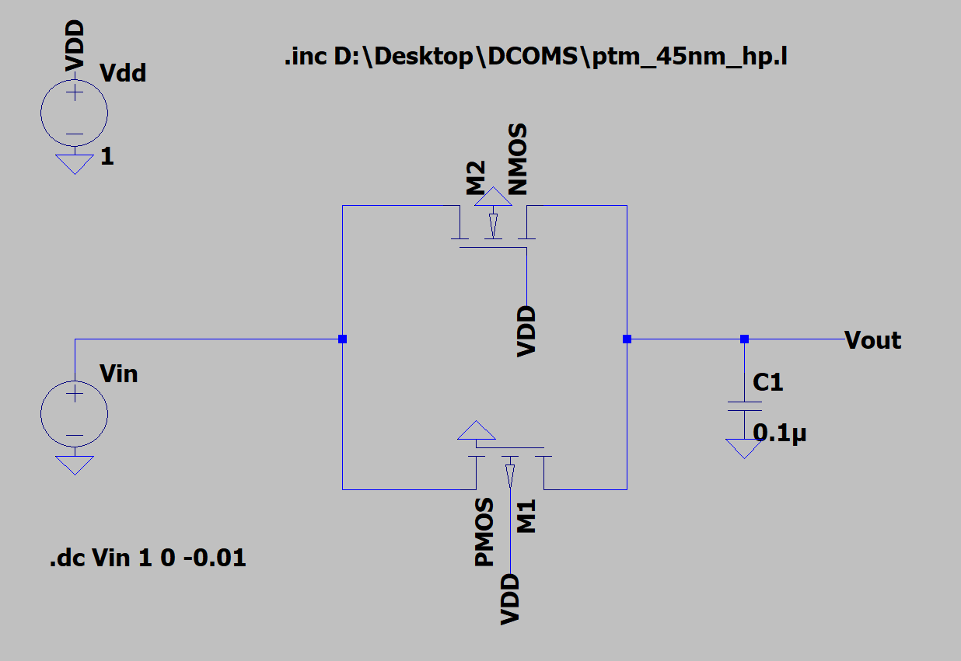

Discharging:

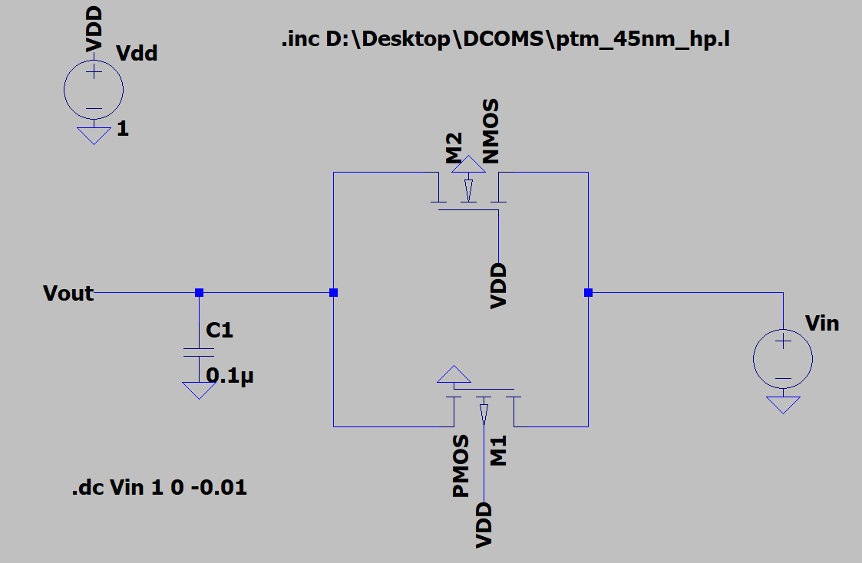

Graphs:

Charging:

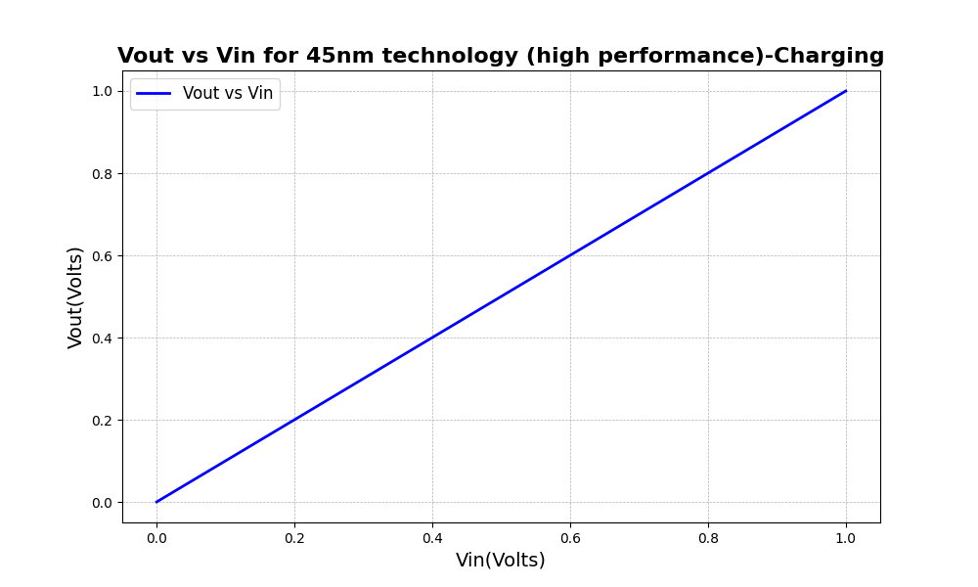

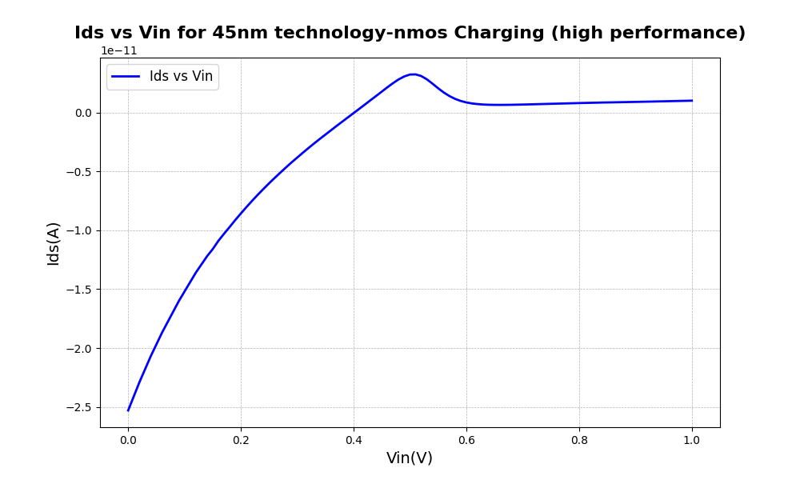

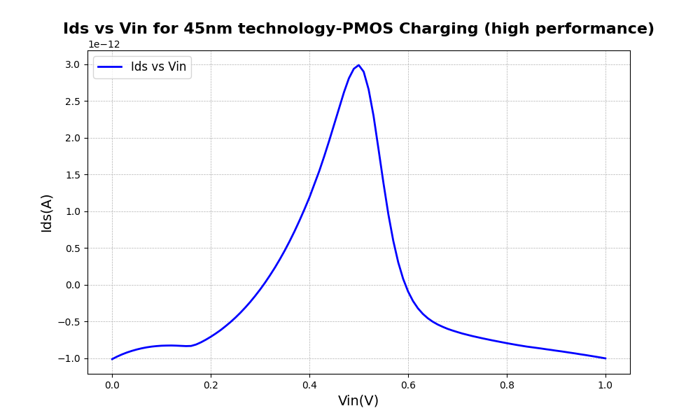

Discharging:

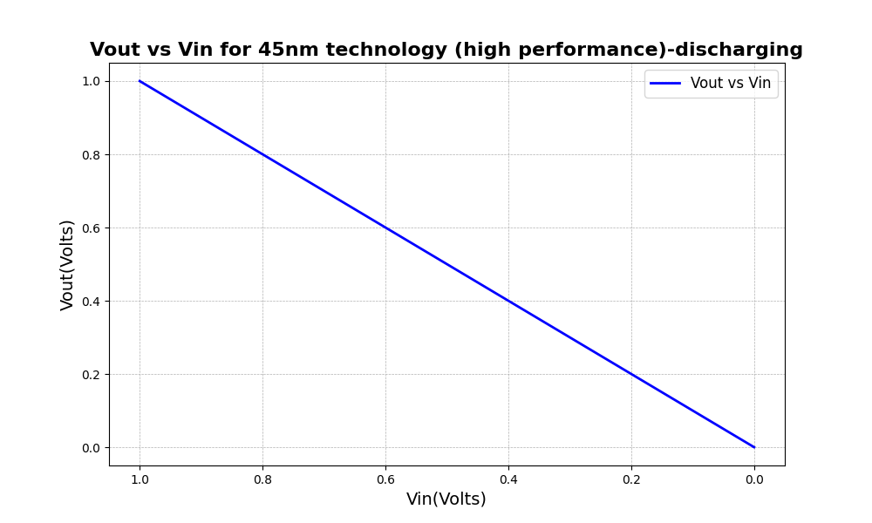

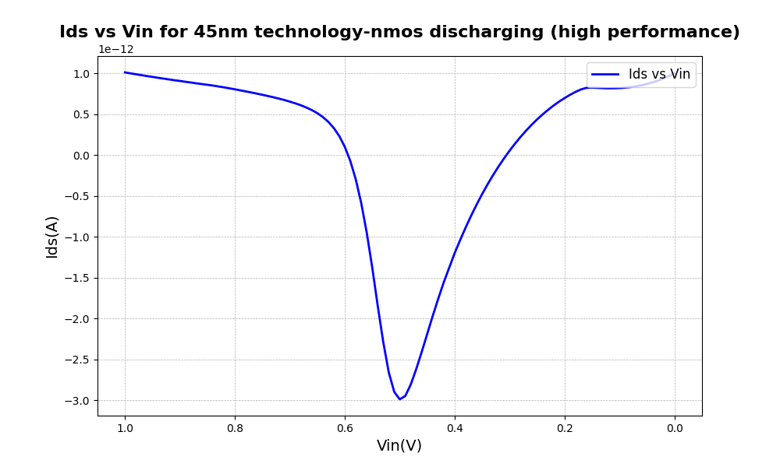

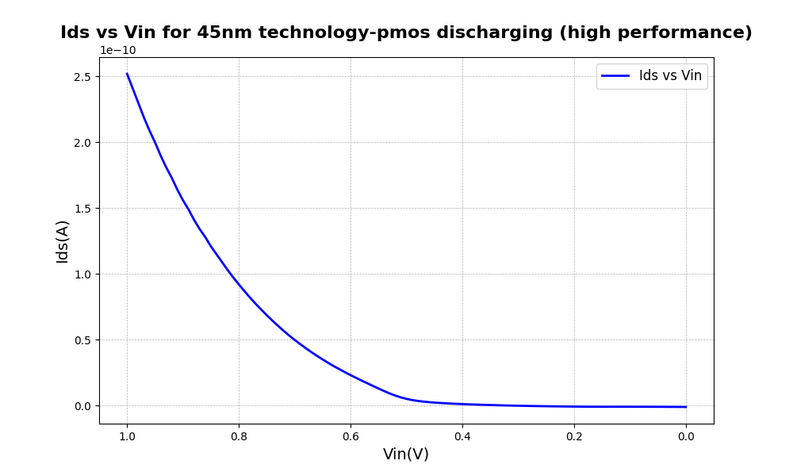

=>1.b Manual Handwritten and MatplotLib

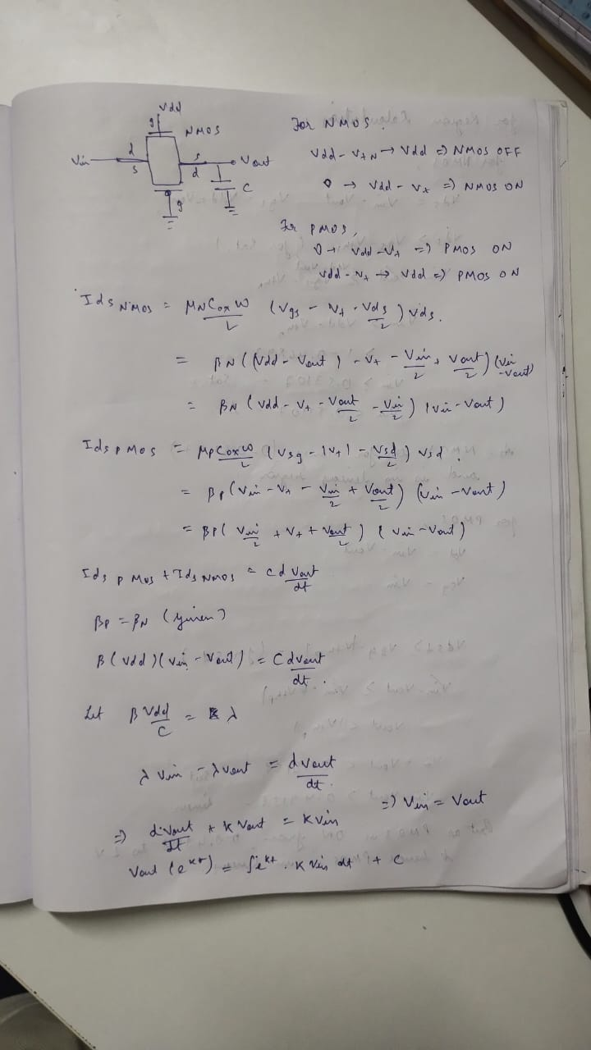

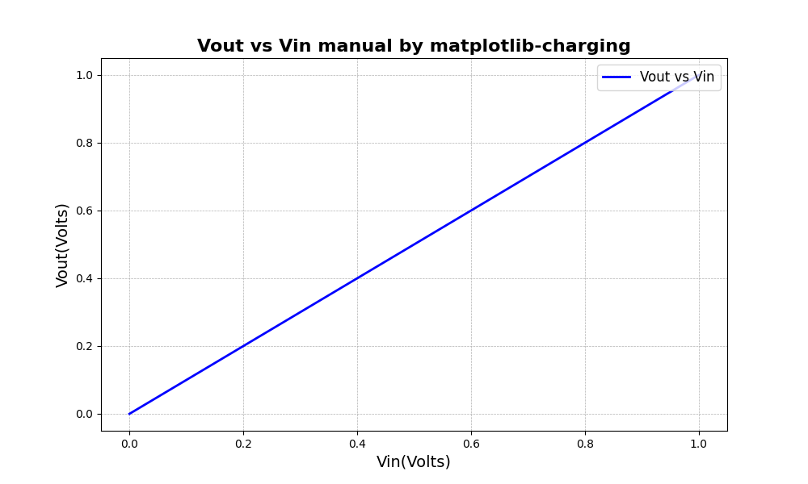

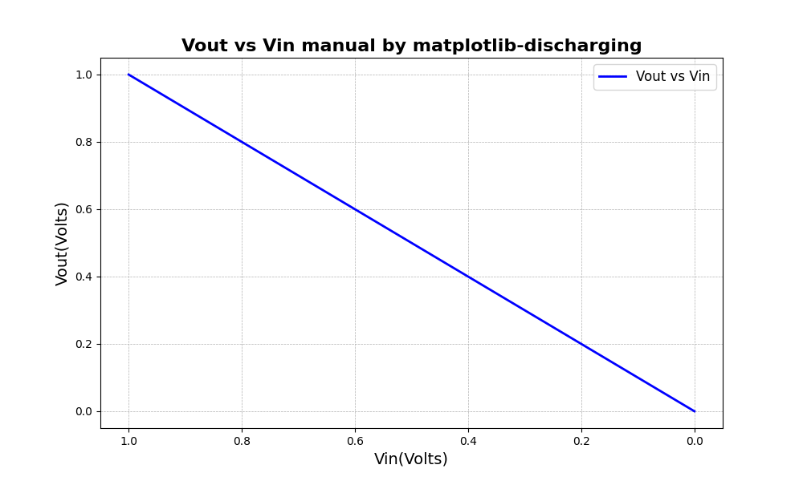

For Charging:

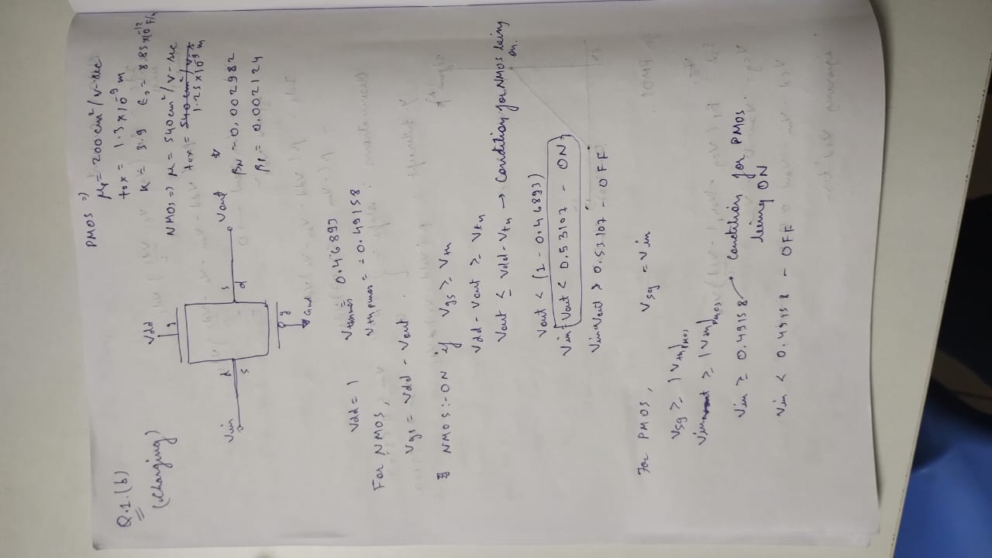

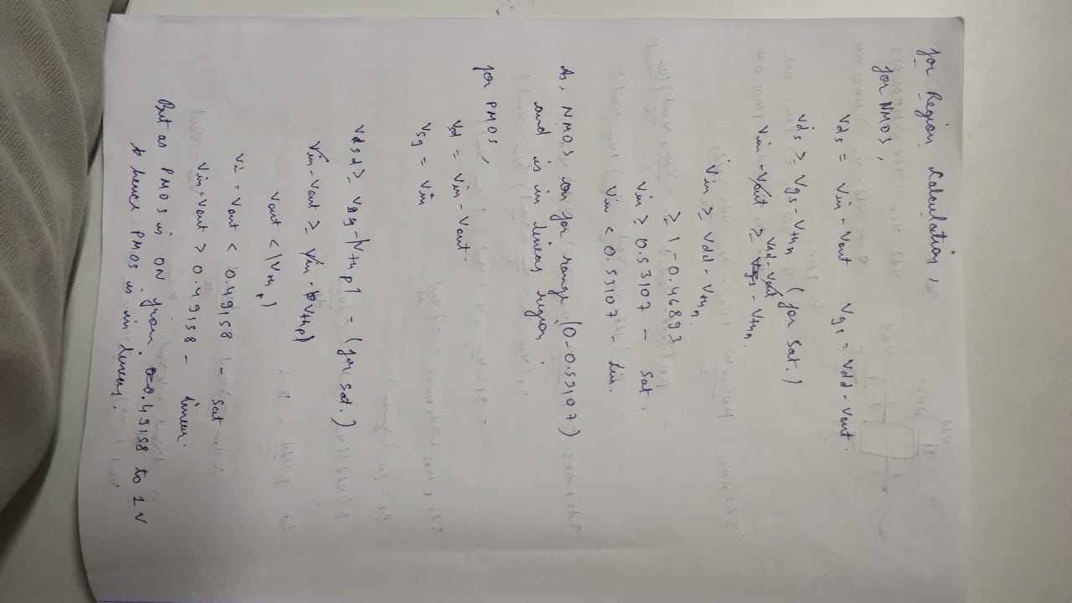

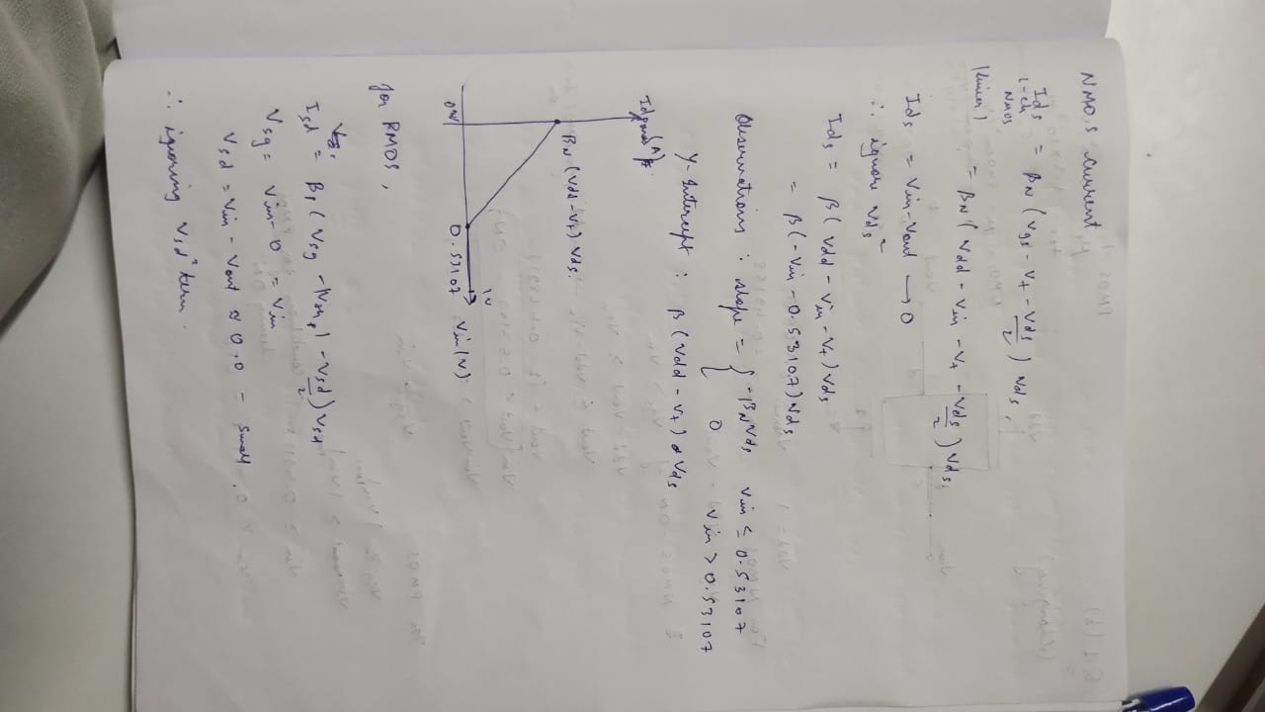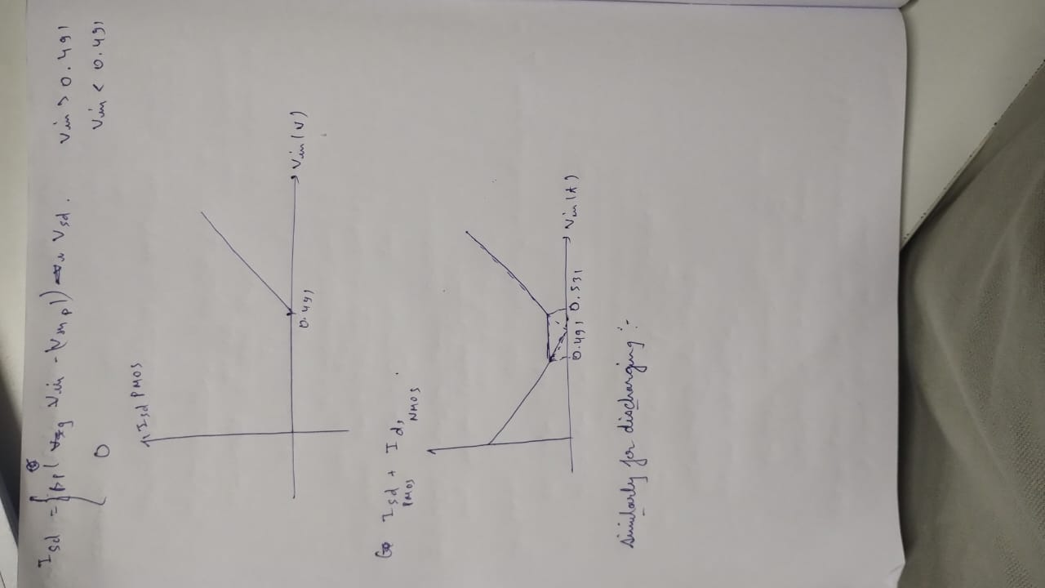

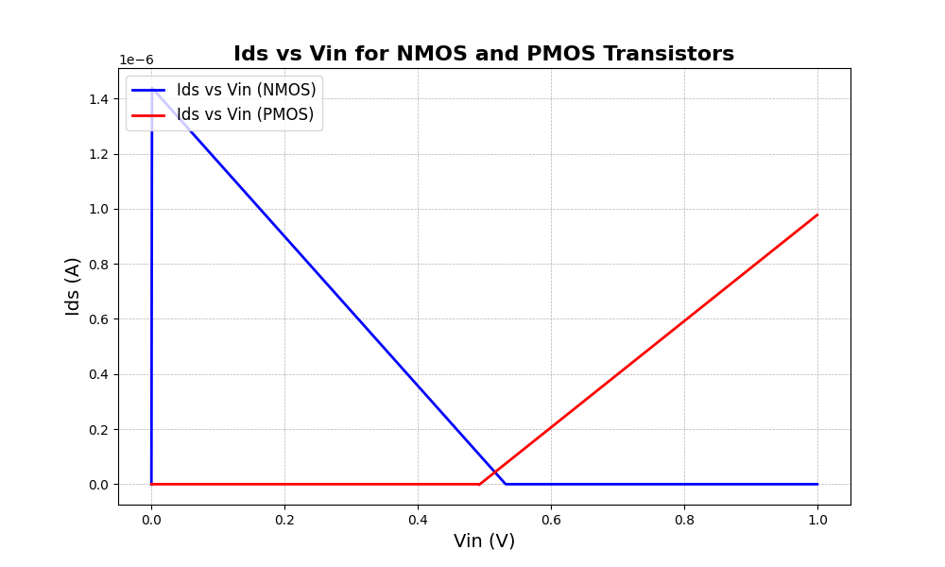

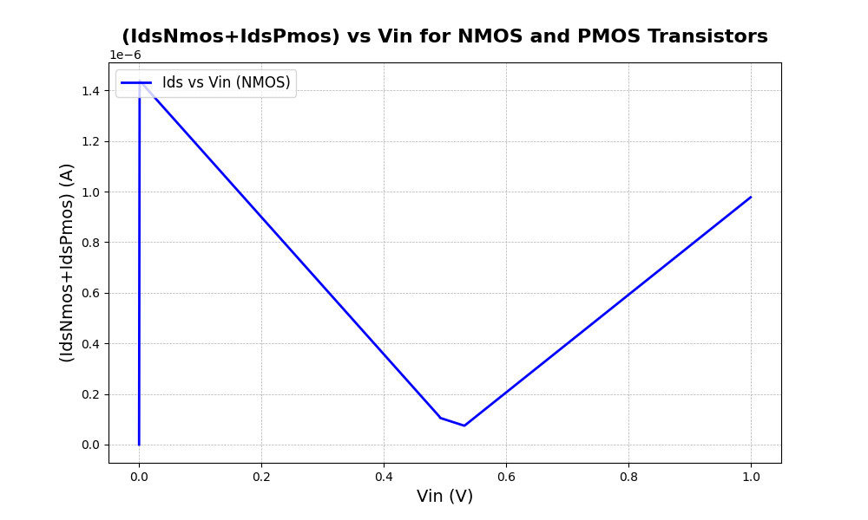

For Discharging:

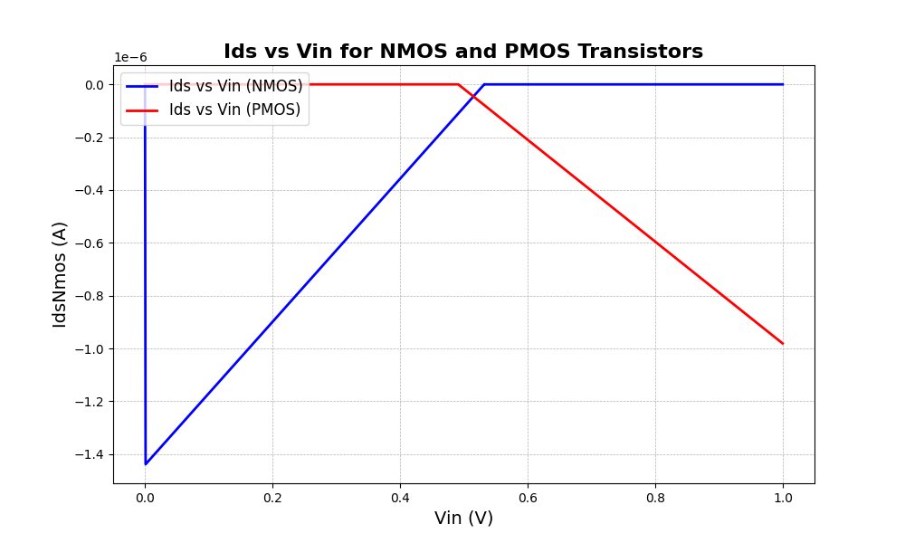

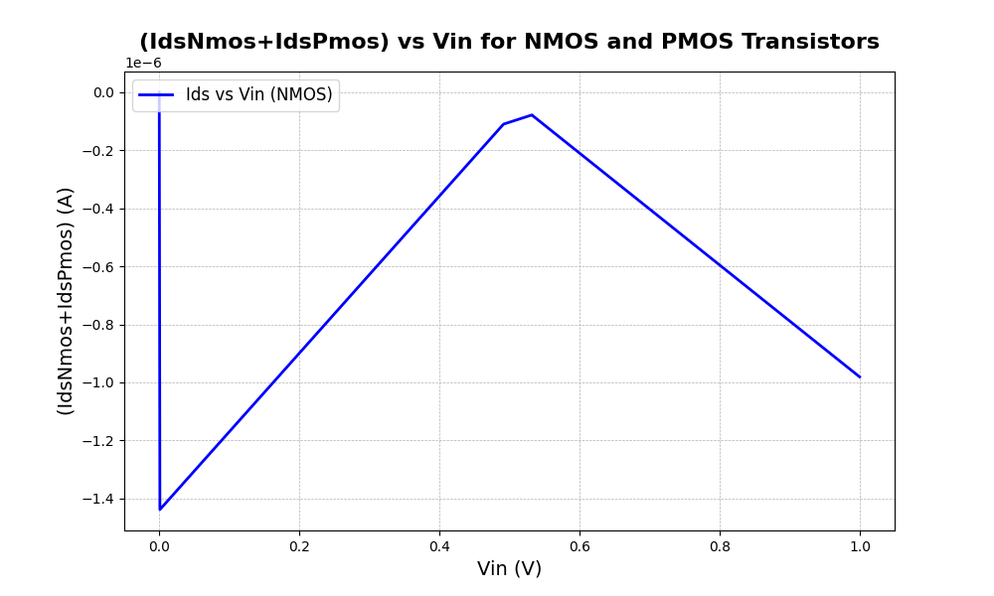

Q2.

Draw a plot showing C-V characteristics of an NMOS transistor. Consider NMOS transistor of 45 nm and 22 nm technology node for a channel length of 1 micron, width of 360 nm using LT Spice. (Note that C-V graph should not be a print-screen of LT Spice, but rather a readable plot of the data captured from LTSpice ).

=>

Schematics:



Graph:

